ASSIGNMENET 3 Flask And Mongodb

1. Create a Flask application with an /api route. When this route is accessed, it should return a JSON list. The data should be stored in a backend file, read from it, and sent as a response.

app.py
from flask import Flask,jsonify
import json,os
app=Flask(__name__)
DATA_FILE="data.json"
@app.route("/api",methods=["GET"])
def get_data():
if not os.path.exists(DATA_FILE):
return jsonify({"error":"Data file not found"}),500
with open(DATA_FILE,"r") as file:
data=json.load(file)
print(data)
return jsonify(data)

if __name__=="__main__":
app.run(debug=True)
data.json
[
{ "id": 1, "name": "Pavan" },
{ "id": 2, "name": "Siddhi" },
{ "id": 3, "name": "Dev" }
]
Output
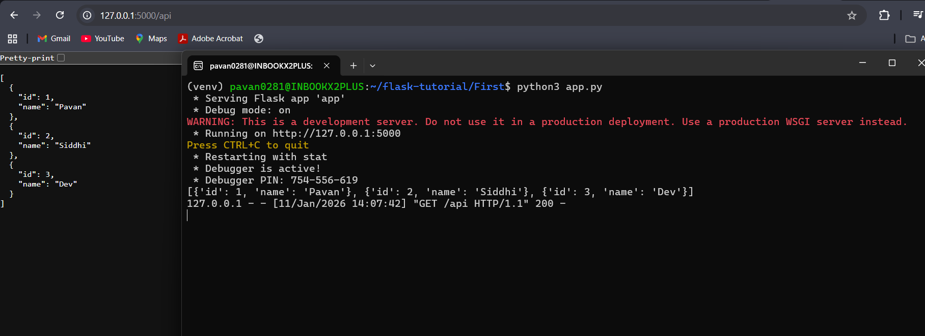

2. Create a form on the frontend that, when submitted, inserts data into MongoDB Atlas. Upon successful submission, the user should be redirected to another page displaying the message "Data submitted successfully". If there's an error during submission, display the error on the same page without redirection.

templates/form.html
<!DOCTYPE html>
<html>
<head>
<title>Submit Data</title>
</head>
<body>
<h2>User Form</h2>
{% if error %}
<p style="color:red;">{{ error }}</p>
{% endif %}

<form method="POST">
<label>Name:</label><br>
<input type="text" name="name" required><br><br>

<label>Email:</label><br>
<input type="email" name="email" required><br><br>

<button type="submit">Submit</button>
</form>
</body>
</html>

templates/success.html
<!DOCTYPE html>
<html>
<head>
<title>Success</title>
</head>
<body>
<h2>Data submitted successfully</h2>
</body>
</html>

app.py
from flask import Flask, render_template, request, redirect, url_for
from pymongo import MongoClient
from dotenv import load_dotenv
import os
load_dotenv()
MONGO_URI = os.getenv("MONGO_URI")
app = Flask(__name__)
client = MongoClient(MONGO_URI)
db = client["testdb"]
collection = db["users"]
@app.route("/", methods=["GET", "POST"])
def form():
error = None
if request.method == "POST":
try:
name = request.form["name"]
email = request.form["email"]
collection.insert_one({"name": name, "email": email})
return redirect(url_for("success"))
except Exception as e:
error = str(e)
return render_template("form.html", error=error)
@app.route("/success")
def success():
return render_template("success.html")
if __name__ == "__main__":
app.run(debug=True)

OUTPUT
